COMP 3700 Project 2: Testing Document

1. Add New Product Screenshots

Start the store server then start the store manager. Must enter in host:port to connect to server:

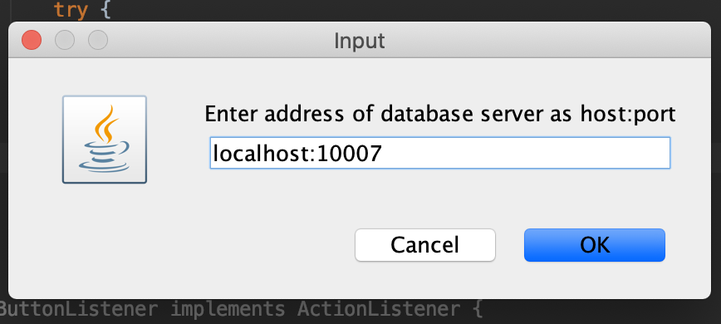

Click on Manage Product after program runs and is connected to server

Main Program Screen:

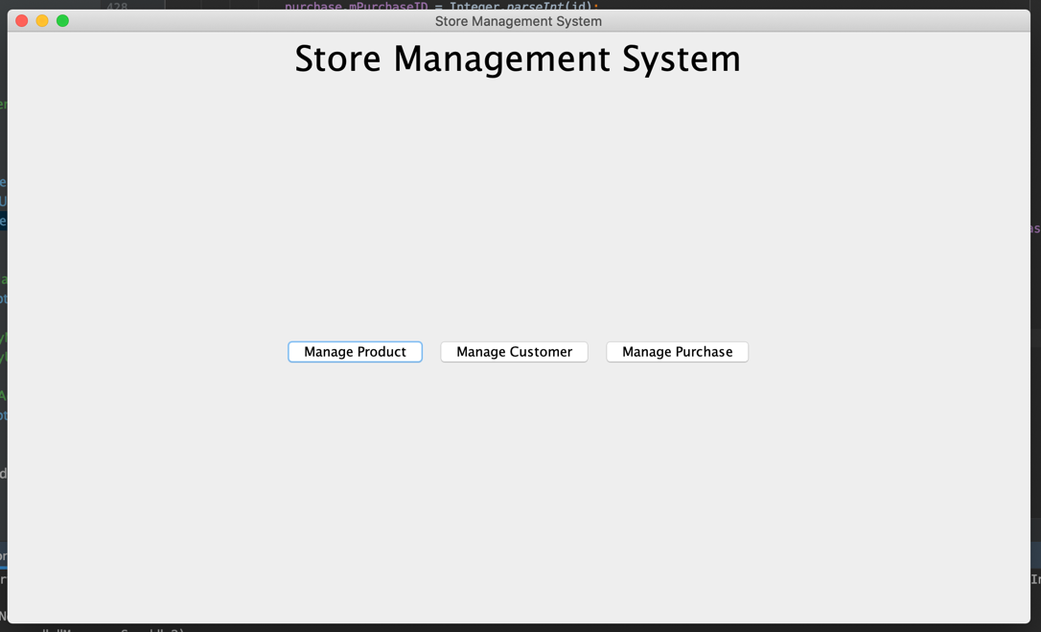

Fill in Product Information

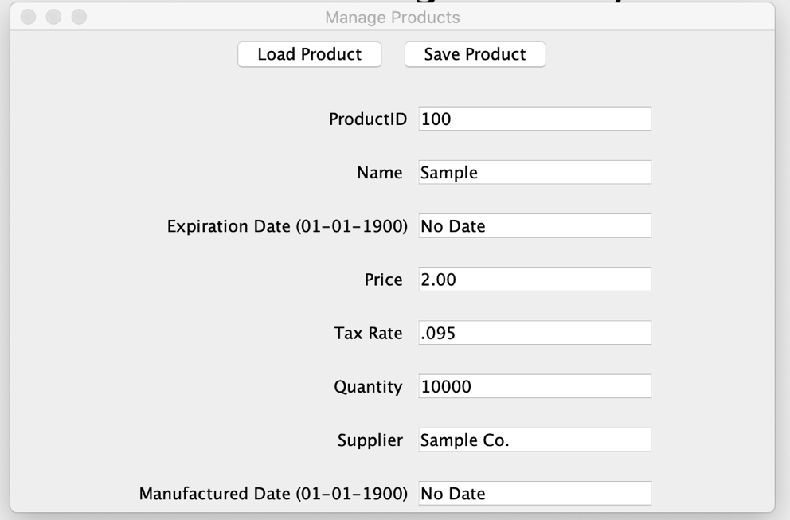

After Clicking On Save Product. Shows Product saved successfully message

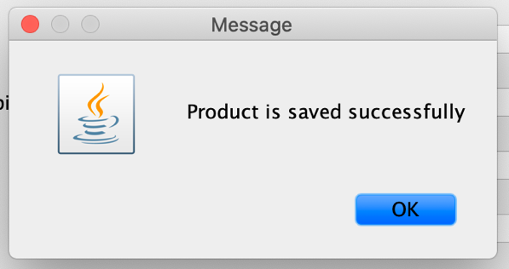

After Clicking Ok, Goes back to manage products for further changes to the system such as adding another product

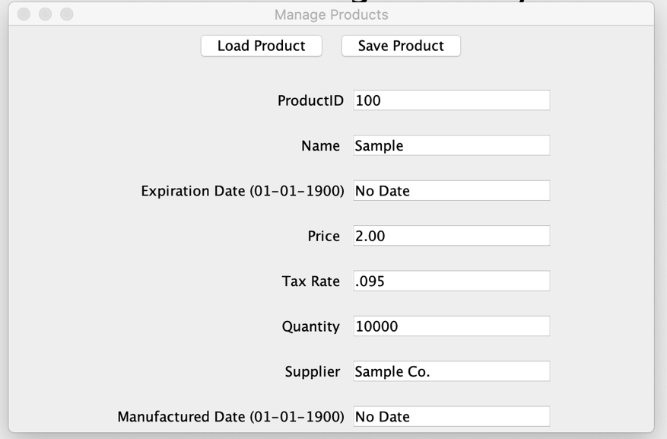

2. Update an existing product

Start the store server then start the store manager. Must enter in host:port to connect to server:



Click on Manage Product after program runs and is connected to server

Main Program Screen:



Type in a product id and press load product button:

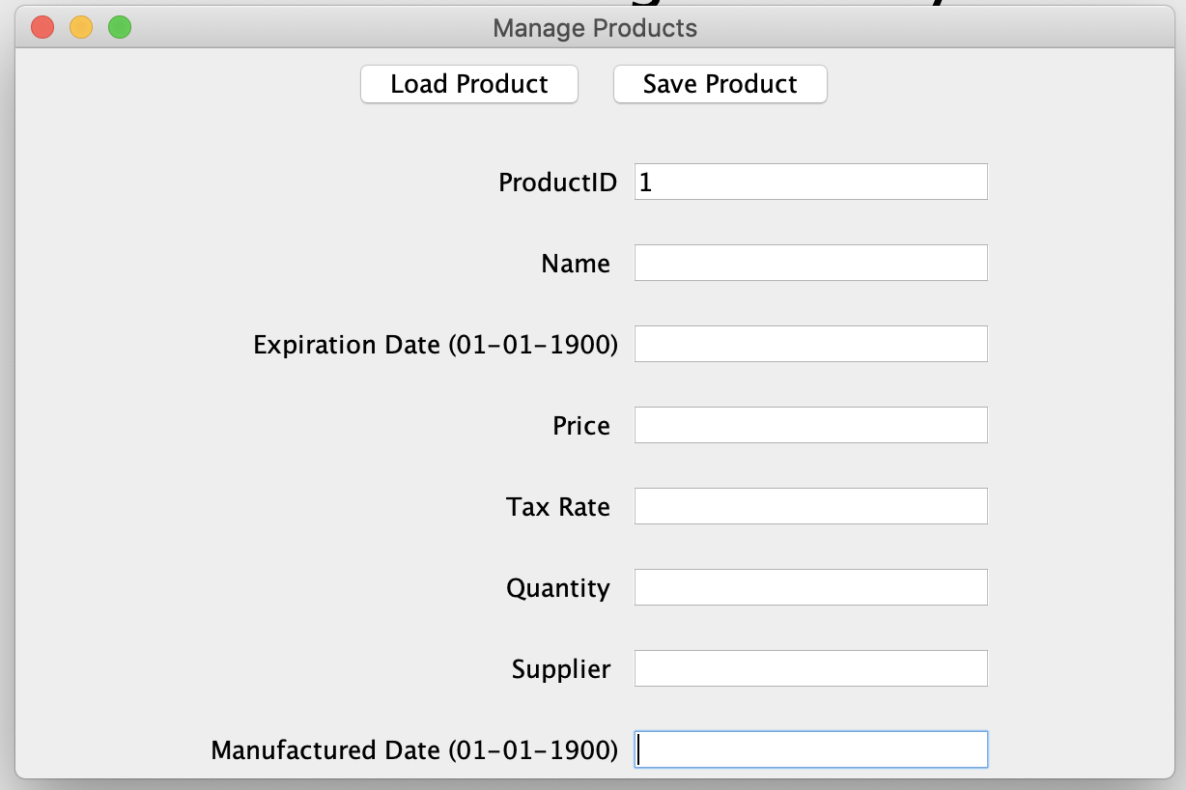

System displays product information:

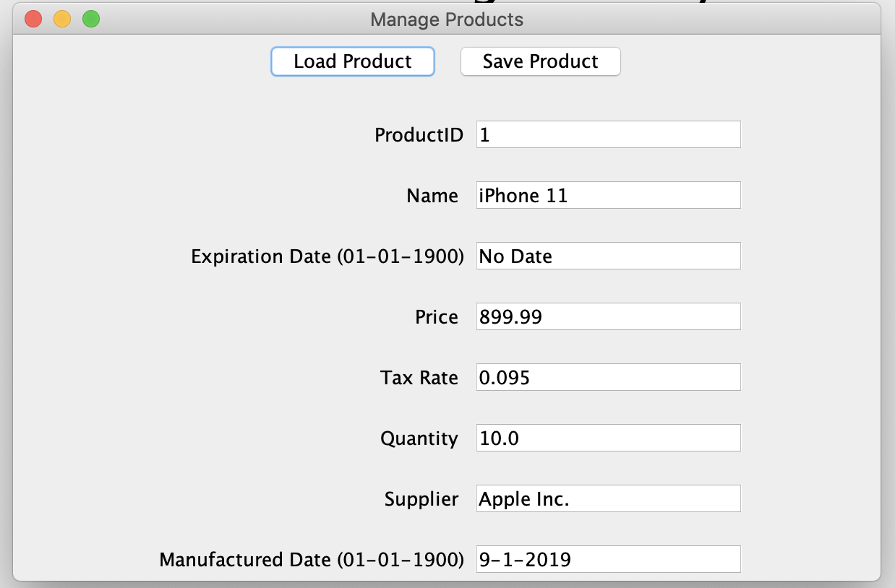

Update the product information: Changed price from 899.99 to 999.99

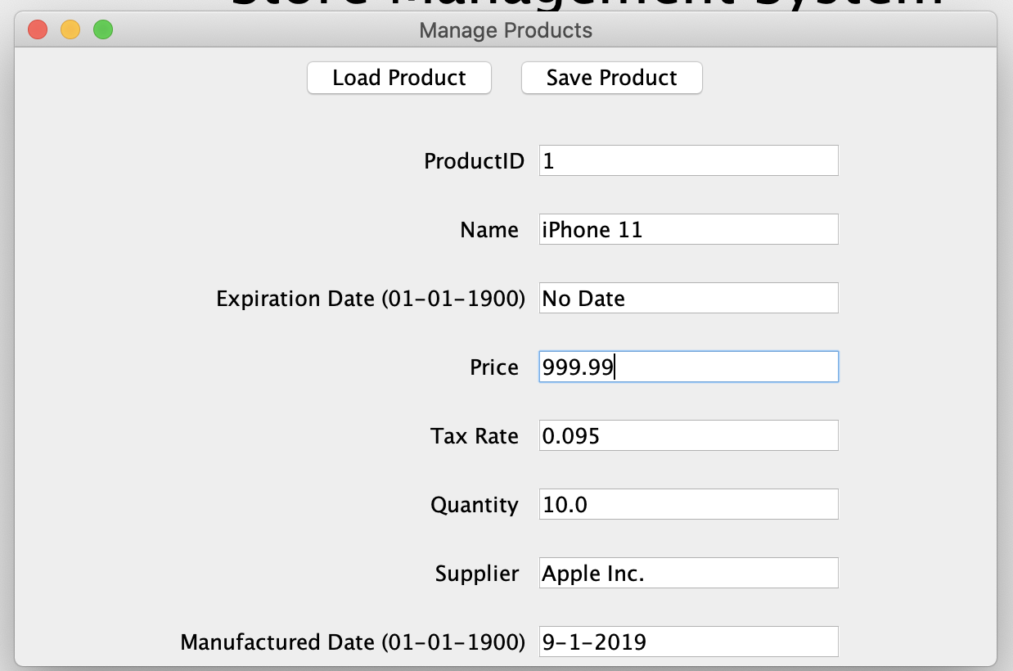

Click on save product and successful message will display:



After Clicking Ok, goes back to manage products for further changes to the system such as adding another product



3. Add a new Customer

Start the store server then start the store manager. Must enter in host:port to connect to server:



Click on Manage Customer after program runs and is connected to server

Main Program Screen:



Fill in Customer Information:

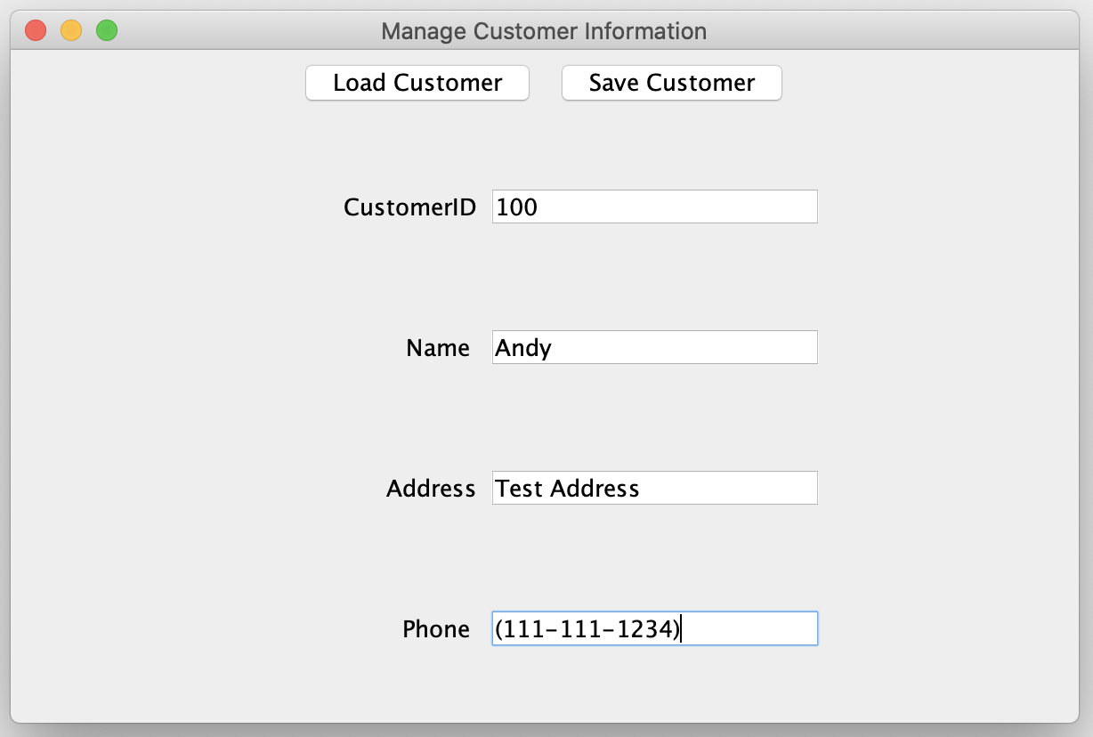

After Clicking on save, customer save successful message shows up:

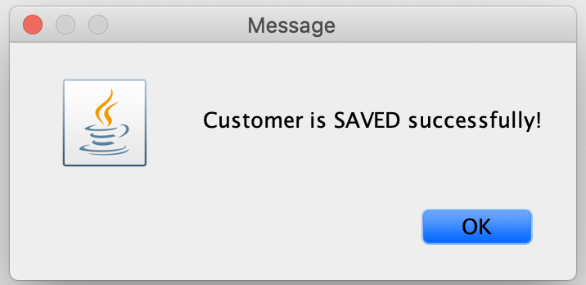

Click OK and it takes you back to manage customers for further updates to the system:



Update Current Customer:

Start the store server then start the store manager. Must enter in host:port to connect to server:



Click on Manage Customer after program runs and is connected to server

Main Program Screen:



Type in a customer id and press load:

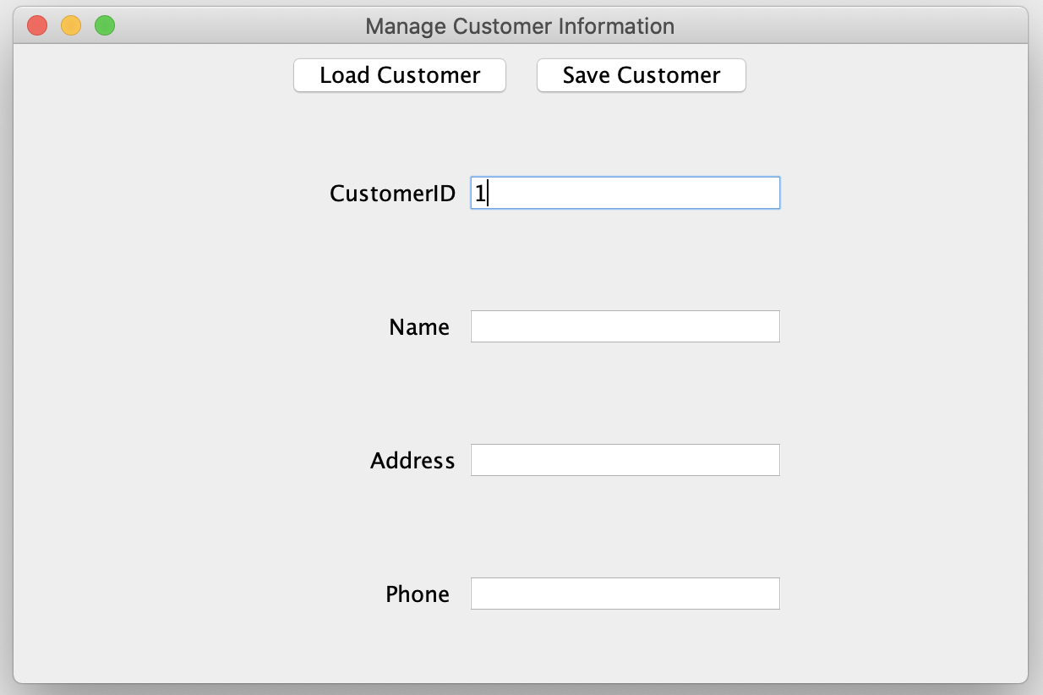

System Displays Customer Information on Screen:

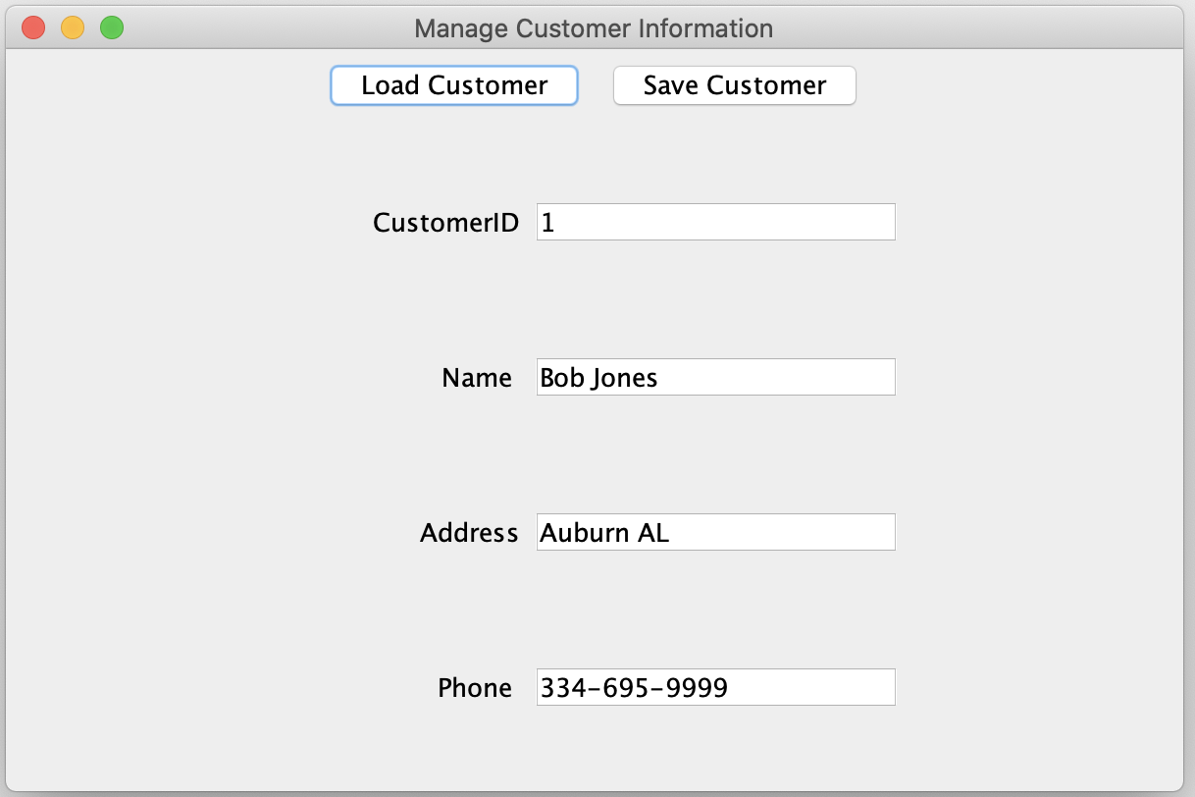

Update product information such as changing the number for the customer:

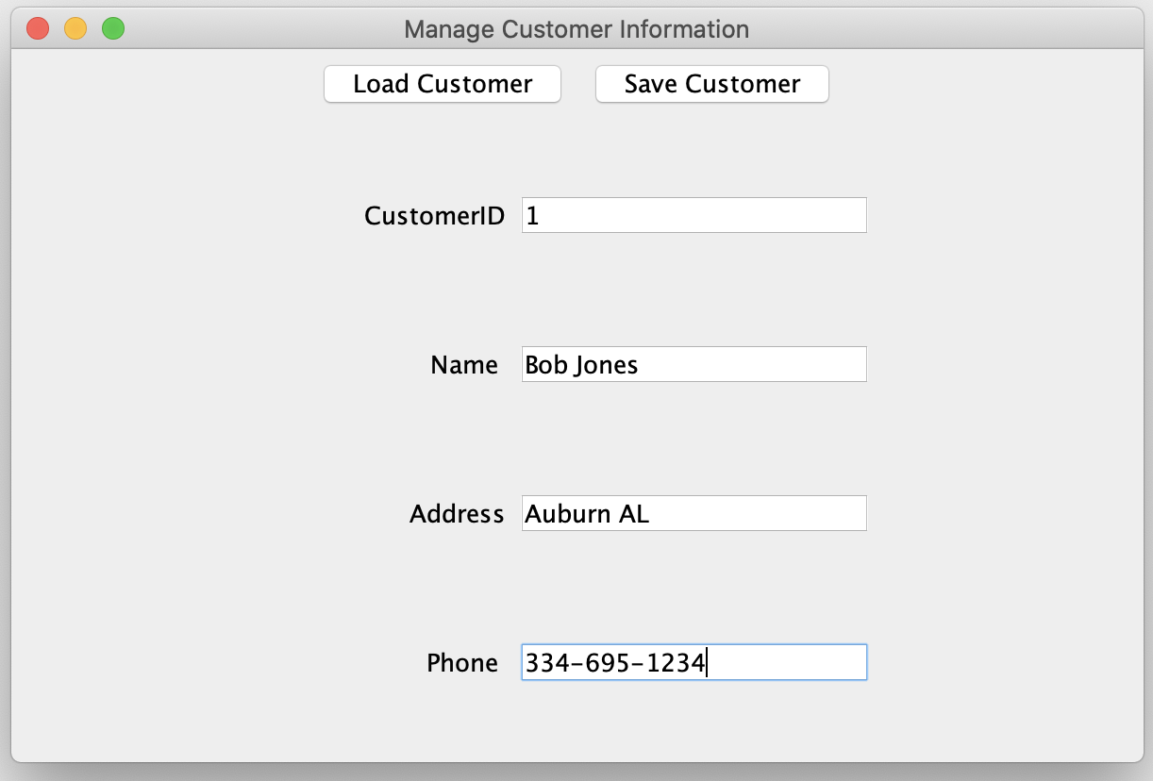

Click on save customer and successful message will show up:



Click Ok and it takes you back the manage customers screen



5. Add a new Purchase:

Start the store server then start the store manager. Must enter in host:port to connect to server:



Click on Manage Purchase after program runs and is connected to server

Main Program Screen:



Fill in purchase information:

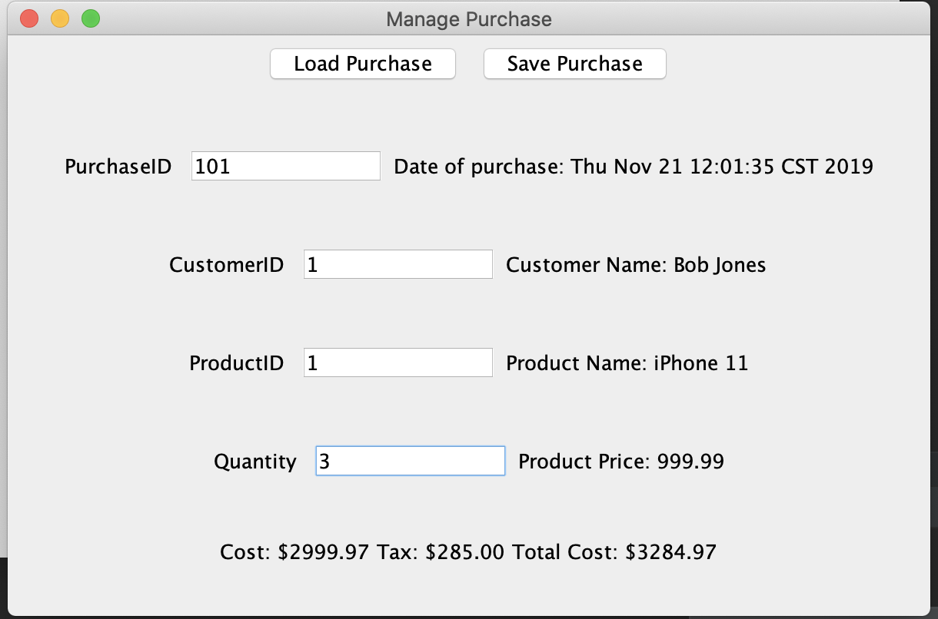

After clicking on save purchase and a successful purchase saved message pops up:

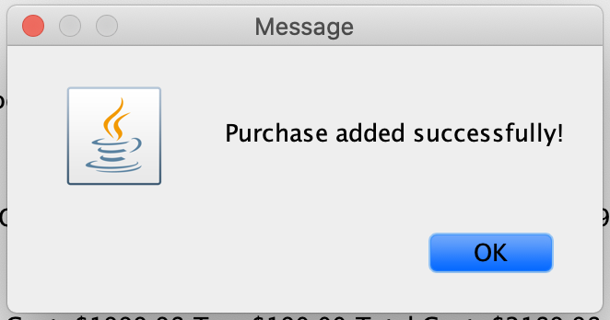

Click OK and it takes you back to manage purchase screen for further updates to the system:

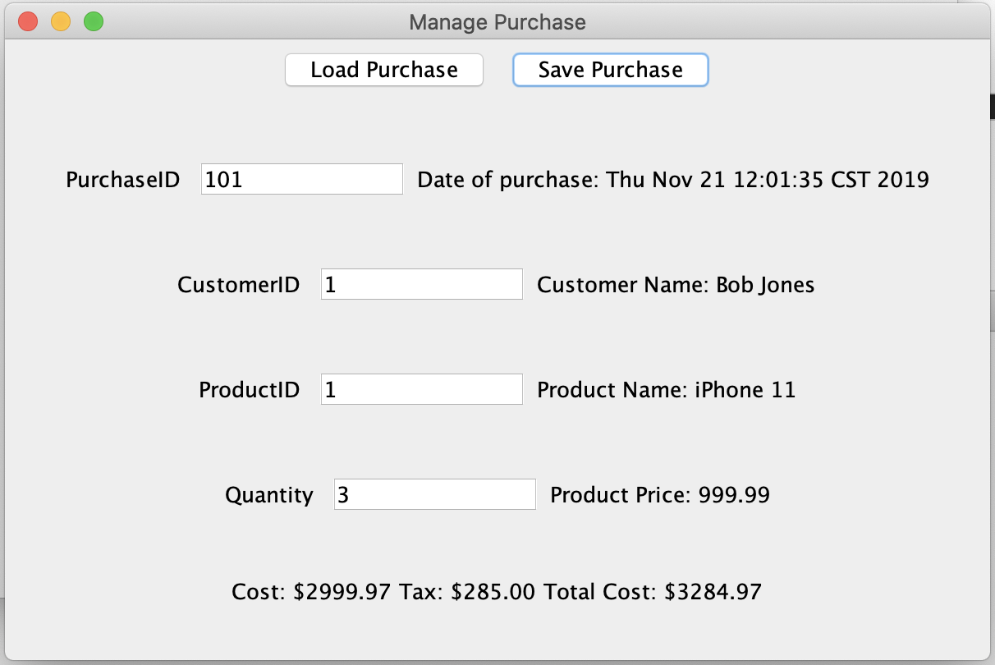

6. Update an existing purchase in the system:

Start the store server then start the store manager. Must enter in host:port to connect to server:



Click on Manage Purchase after program runs and is connected to server

Main Program Screen:



Type in a purchase id and press load:

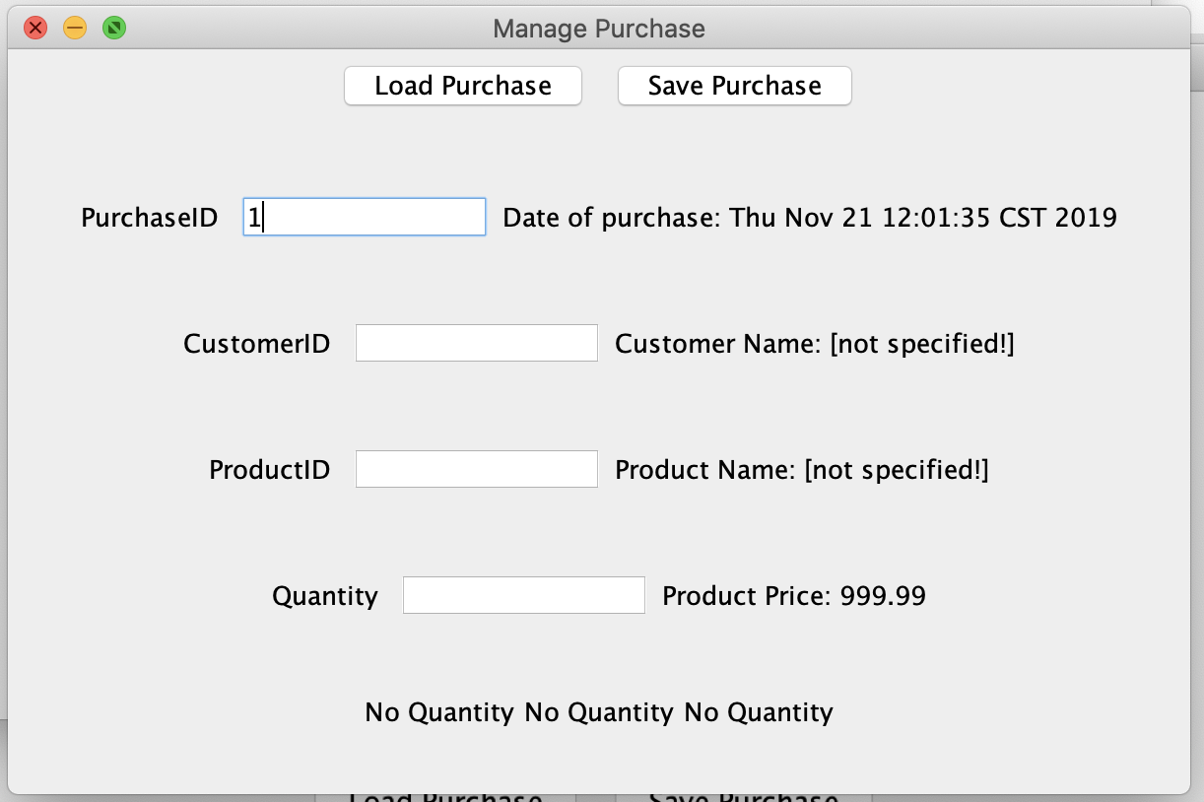

Screen with purchase information after loading:

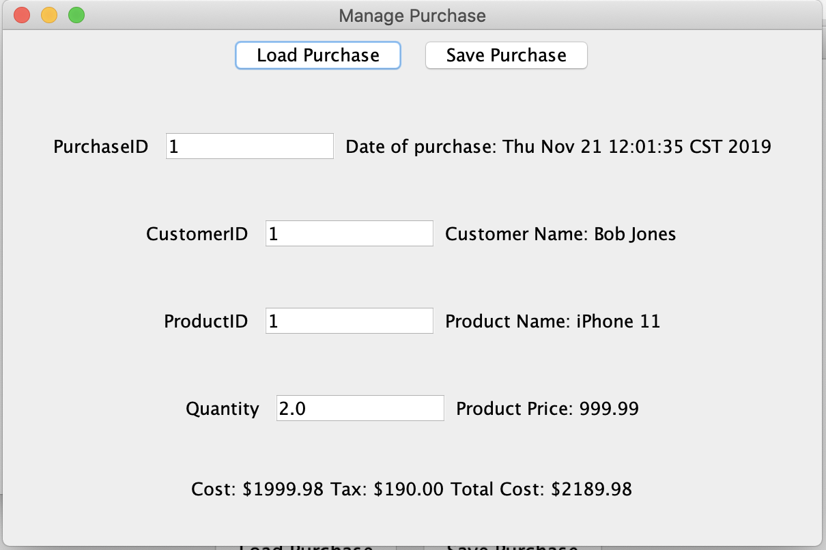

Update purchase information such as changing the quantity:

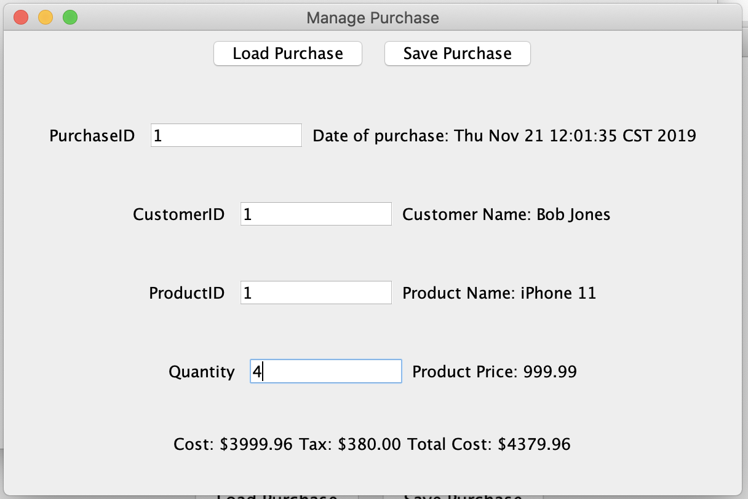

After clicking on save purchase, a successful purchase saved message pops up:



After clicking ok, the manage purchase screen shows up again for further updates:

